THE POWER ANALYSIS TREE
TREE TYPE | What are you looking to influence?
Your tree type | Key Considerations
 | This might be a geography, an organisation or a policy issue. Be as specific as possible.
FRUIT | What are you trying to achieve through your influencing work?
Your fruit | Key Considerations
1.  2.  3.  4.  5. | To be effective, your objectives should be SMART:  - Specific: target a specific area  - Measurable: quantify or at least suggest an indicator of progress.  - Assignable: specify who will do it.  - Realistic: state what results can realistically be achieved, given available resources.  - Time-bound: specify when the result(s) can be achieved.

Key Considerations
Think about the prioritisation of these relationships and how they relate to each other. Don’t just focus on those in the centre – those in the outer rings who may be gatekeepers or influencers are often crucial.
TRUNK | Who are you trying to influence?
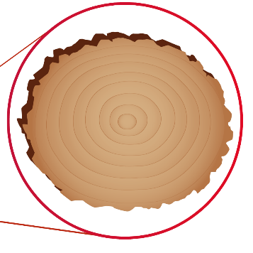
1.
2.
3.
4.
5.
6.
7.
8.
ROOTS | Why do they need you and why do you need them?
Your Roots |  | Key Considerations
Your Interest  1.  2.  3.  4.  5. | Their Interest  1.  2.  3.  4.  5. | Presenting what you want as part of an offer is far more impactful than a simple ask.

BRANCHES | How would you practically build the relationships you need?

Your Branches | Key Considerations
1.  2.  3.  4.  5. | Make sure the tactics you choose clearly achieve your SMART objectives. Again, be as specific as possible.

