OUR STORIES
Please make some notes (if you are early for the session, thank you!)

WHY MY ORGANISATION EXISTS (IN 10 WORDS OR LESS) ………

WHY I DO WHAT I DO (IN 10 WORDS OR LESS)………

RESOURCES

https://www.ted.com/talks/simon_sinek_how_great_leaders_inspire_action
https://www.comnetwork.org/insights/the-case-for-explanatory-stories/

https://www2.warwick.ac.uk/fac/arts/classics/students/modules/introhist/usefuldocuments/thucydides_v.84-116.pdf
http://www.housing.org.uk/get-involved/promoting-our-sector/owning-our-future/build-the-relationships-we-need/power-analysis/

Host Leadership Mark McKergow and Helen Bailey
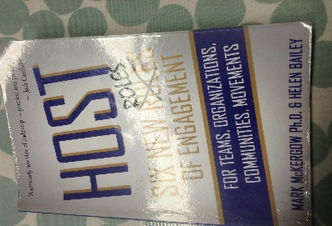

A crowdfunding opportunity for Llamau’s helpline
https://www.crowdfunder.co.uk/youth-homeless-helpline/

